**Inhibition and Damage in DEBkiss (same concepts as earlier notes but with formulae)**

**RMN: 11/9/23**

According to Muller et al. (2019):

*Inhibition is the process by which a compound reversibly binds to an enzyme and thereby impedes its activity; enzymatic activity is fully restored upon dissociation of the inhibitor.*

*Damage is* *the process by which a detrimental agent irreversibly destroys the functionality of an SU, which then either needs to be replaced through de novo synthesis or requires restoration through a repair process*.

**Inhibition of assimilation**

In DEBkiss, all biosynthesis processes have rates proportional to the assimilation rate. The loss rate of egg buffer is equal to  and the material available to growth is . Thus, with the strict Muller et al definition, inhibition corresponds to a reduction in the assimilation parameterbut NOT a change in any yield coefficients.

In DEBkiss, assimilation can be regarded as processing of single resource (e.g. food or yolk) by a SU (generalized enzyme). Muller et al, show 5 different ways in which an inhibitor can slow the process (their Fig 1) and consistent with (cumbersome) terminology used in enzyme kinetics refer to them as partial mixed, mixed, noncompetitive, competitive and uncompetitive inhibition. We have no data that would allow us to choose among these options, but it is helpful to note that with all options but one, the resulting formula for the flux involves terms coupling resource density and the half saturation constant for resource uptake (not just the scaled functional response, *f*) with a term characterizing the inhibitor. We have no information from which to infer the values of these quantities. The exceptional option is **noncompetitive inhibition** (Muller et al, eq 7) for which inhibition is represented by a multiplicative factor involving the flux of an inhibitor, represented by . The distinguishing property of noncompetitive inhibition is that the effect of the inhibitor (here, for example IGFBP-1) is the same for both SUs bound to substrate and free. I suggest using this model because it has fewest data demands.

The Muller et al models assume an input flux of an inhibitor, denoted by. It seems reasonable to assume that this input of inhibitor decreases with increasing DO and that it becomes very large as DO drops close to DOC. One simple form with this property would be

 (1)

Eq. (7) in Muller et al, rewritten to match your DEBkiss notation would then have the form[1]

, (2)

and the “correction term” required for your model is

 if  (3)

It would appear that we have two new parameters *ki* and *Z*. However only their product appears in the formula so there is no loss of generality in setting *ki* = 1 and getting

 if  and *c*=0 otherwise (4)

Sample plots for this correction factor are show below. I set , a visual estimate from your Fig 4.3.

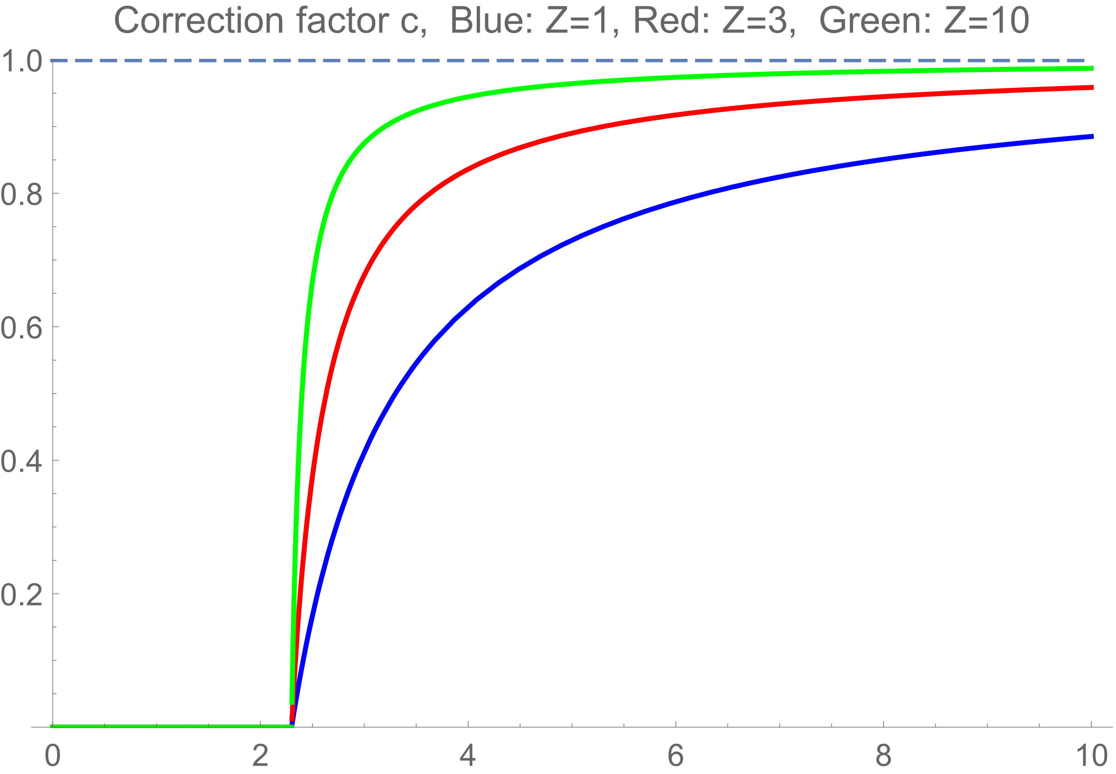

**Damage production**

Damage can (directly or indirectly) impact any of the model parameters, including yield coefficients. Muller et al present explicit SU models for damage production, but absent details on mechanisms, I see little value in creating a new damage module with an additional state variable representing damage. Indeed Muller et al (last para of section 2.2) say that if damage production is much slower than the turnover of any of the SU states, damage models are equivalent to analogous inhibition models. This suggest to me that it is also defensible to apply the correction factor in equation (4) to yield coefficients, but now interpreted as damage rather than inhibition.

**Maintenance and Mortality**

It remains to consider rates that *increase* as *DO* drops close to *DOC*. The obvious (perhaps lazy?) option is to stick with your equation 4.3, but now using the reciprocal of our new value for *c*. It might be possible to formalize this a little by defining a stress function, but I don’t currently see any benefit.

1. Note that the symbol *jA* has different meaning in your paper and Erik’s.